Current Market View – September 2025

Investment Markets
Global Markets
Global markets continued the positive trend and lifted higher for most developed regions over September 2025. Investors have discounted the inflation and interest rate impact for asset prices and continue to add to their “risk-on” positions. The market appreciated the break in the tariff related announcements and resumed the “buy the dip” mentality of recent times.

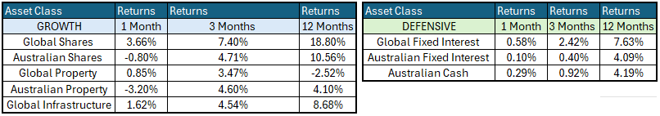

The Federal Reserve Bank (the Fed) remains focussed of the inflation impact of the tariffs; however, the economy is doing well with limited impact on inflation from the introduction of the US tariffs experienced to date.
Global Share Markets
The US share markets are factoring in another 25-basis point cut in the Federal Funds target cash rate for the upcoming FOMC meeting due to start 28th / 29th October 2025. The Global Markets were mostly positive over September 2025 minus Australia:
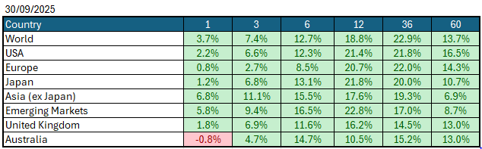
Data Source: AFM as of 30th September 2025.
Global Bond Markets
Bond markets are still not convinced by the tariff reprieve believing that the outcome will eventually lead to further inflation however, the Central Bank bias towards lower interest rates is leading the path forward with yields retreating ahead of the next US FOMC meeting. The long end of the interest rate curve is sensitive however managed to trade lower in yield terms reflecting the expected 25-basis point shift next week.
Interest rate markets in the US month over September 2025 eased with the 10year Government bonds falling to 4.1338%. UK10year Gilts were trading at 4.508% on 30th September 2025.
Domestic Bond Markets
For Australia, the latest inflation prints for (year-on-year) August 2025 increased to 3.0% which was an increase from 2.8% in July 2025. The RBA board meeting held on 29th/30th September 2025 saw the target cash rate held steady at 3.60% following a 0.25% cut in the August Meeting. The next RBA Monetary Policy meeting is due on the 3rd/4th November 2025.
Investment Climate
With the US tariff negotiations ongoing, and investors getting more comfortable with the expected outcomes, risk-on trades dominated activity. This downside risk remains a real threat given that all countries that trade (exporters) with the US are impacted by the tariffs. For Australia, the impact is contained to the steel and aluminium (+25%) and everything else 10% of exports to the US for the moment. At this stage, Australia has not retaliated with any US tariffs however, the AUKUS submarine agreement is now under review which may impact our defence needs. Australia has minimal exposure to US exports, having run a trade deficit with the USA since the Korean War. Australia’s largest export to the USA is gold ingots which is not subject to tariffs.
Medium-term investors are encouraged by the anticipated gradual easing of interest rates; however, the unsettled nature of the share and bond markets clouds the short-term direction. The soft-landing expectations and economic recovery are still supported by the economic data, despite the recent volatility.
The risk is that the conflict in the middle east may escalate and involve neighbours which could then inflame the situation, though this risk has fallen sharply in October with the Gaza peace accords.
The medium-term view remains positive for returns as the US Fed Chair; Jerome Powels appears to have shifted his stance to further easing of interest rates in the US for the rest of 2025. At the 16th/17th September 2025 Meeting, the Fed eased interest rates by 0.25% to 4.25%, with the market anticipating another 0.25% cut at the 28th/29th October 2025 Meeting.
Longer term investors are optimistic for a recovery period ahead. Global Central Banks continue to indicate a resolve to get inflation under control however, the economic data is showing signs of a stabilising despite inflation being elevated and every indication is for future easing in monetary policy to be possible over 2025. Remember markets are forward looking so the support now is reflecting the expectations for conditions in March 2026.
The following commentary is based on month-end closing prices as of 30th September 2025:
Global share markets over September were firm but mixed in Asia with returns recovering despite the ongoing tariff situation and changing bouts of volatility after every tariff announcement. The AUD/USD strengthened from 0.6538 to 0.6613 (+1.18%).
The US Fed eased the monetary policy to the target range for federal funds of 4.00%-4.25% when it met on the 16th/17th September 2025. Investors are gaining more confidence that the economy is headed for a soft landing despite the intermittent bouts of volatility. The next Fed meeting is on the 28th/29th October 2025.
The underlying short-term theme is “risk-on” for shares.
The situation in Russia/Ukraine conflict remains unchanged however the latest conflict between Israel, Gaza (Hamas) has cooled.
Investor Focus
For Australia, investors focussed on the following issues:
- Cost of living expenses and the impact on consumer spending.
- Commodity prices (post China policy changes) and the impact on company profits.
- The level of interest rates and the delicate position of the RBA given the global volatility in markets.
- US tariffs and the impact on Australia’s exports (if any).
- Inflation (Y-O-Y) increased to 3.0% in the month of August, with the next quarterly cpi being released on 29th October 2025.
- Government spending and the rising debt level.

Currency
The Australian Dollar closed stronger AUD/USD 0.6613 at the end of September 2025, from 0.6538, which was negative for returns for investors who held offshore assets unhedged.
Currency forecasters see the AUD/USD range between:
0.5750 and 0.6750 cents in the medium term and most likely to trade within the:
0.5500 to 0.7500 range in the longer term.

Australian Economy
Australia’s latest GDP data for the second quarter of 2025 revealed an annual growth rate of 1.8% which was up from 1.3% in the first quarter of 2025. Unemployment remained steady at 4.2% in August 2025. The Y-O-Y inflation rate increased to 3.0% in August 2025 up from 2.8% in July 2025, which is just within the Reserve Bank’s targeted 2% to 3% target range.

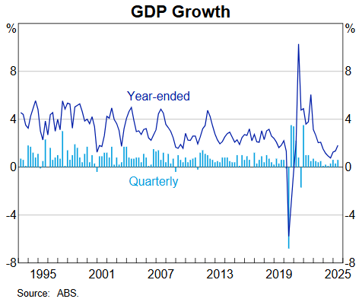

Current Market View

Domestic View
The overall investment view for shares “risk-on” over the short term, “cautiously optimistic” over the medium, and long run as interest rates are expected to continue to trend down post the tariff implementation and future anticipated easing of Monetary Policy by the RBA.
The market is expecting a good chance of a 0.25% cut to interest rates at the coming RBA monetary policy meeting on the 3rd/4th November 2025. This will help borrowers in the short-term and support share market valuations.

Global View
Global share market remains positive despite the Middle East conflict which we expect will result in Central Banks looking to ease interest rates to prevent further fallout from the events where they can however, the countries impacted by trade tariffs directly are likely to hold rates while they assess what will be the inflationary impacts of the new tariffs.
Global markets have dealt with tariffs in the past and they will settle given the charges have only just begun. The implementation of the tariffs will take time to work through and in the interim, markets will remain on alert. We remain optimistic about the future despite the tariffs and the interruption to global trade.
Where to From Here?
Tariffs have had a muted impact on our resource sector to date although the market did overreact on the downside initially most of which has been unwound of late.
Company reporting season in August 2025 was solid with guidance is being met or exceeded in key industries which will support the positive momentum of the share market.
The Middle East political unrest is a background factor that is not easily solved. Let us hope the situation will be contained and a solution that ceases further aggression and violence is forthcoming.
Global markets have already weathered tough conditions over 2024/25 and now there is economic evidence pointing to a soft landing rather than a mild recession in the US and pockets of growth emerging for Europe and Asia.
Markets are forward looking, so it is likely they have taken a positive view of what lies ahead and started adding to positions ahead of the rest of the company reporting season. We suspect we have just seen the start of that recovery process and the recent volatility is simply the ebb and flow of markets.
This document is issued by Atlas Funds Management Pty Ltd. Atlas Funds Management Pty Ltd does not provide any general advice or personal advice regarding any potential investment in any financial products within the meaning of section 766B of the Corporations Act. No consideration has been made of any specific person’s investment objectives, financial situation or needs. The provision of this presentation is not and should not be considered as a recommendation in relation to an investment in any entity or that an investment in any entity is a suitable investment for any specific person. Recipients should make their own enquiries and evaluations they consider appropriate to determine the suitability of any investment (including their investment objectives, financial situation, and particular needs) and should seek all necessary financial, legal, tax and investment advice. Atlas Funds Management Pty Ltd, it’s directors and employees do not accept any liability for results of any actions taken or not taken on the basis of information in this presentation, or for any negligent misstatements, errors or omissions. This presentation is not an advertisement and is not intended for public use or distribution. Past performance of a fund is no guarantee as to its performance.

